- The first step is to dump your model into a Job.Lib File 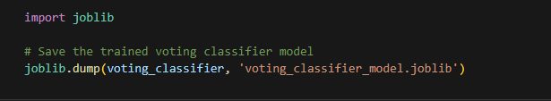
- Then you must save the normalizations so the user inputs are then input into the model the same as the training data.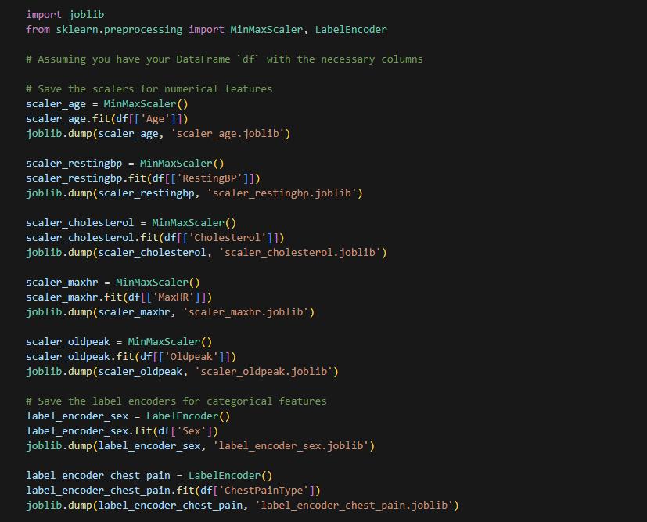
- Next load the models and scalars 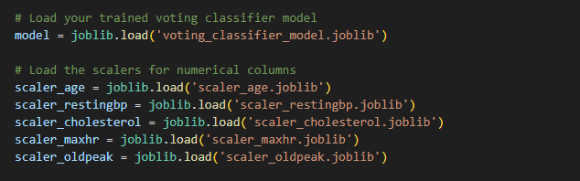
- Next create/use function to normalize the inputs 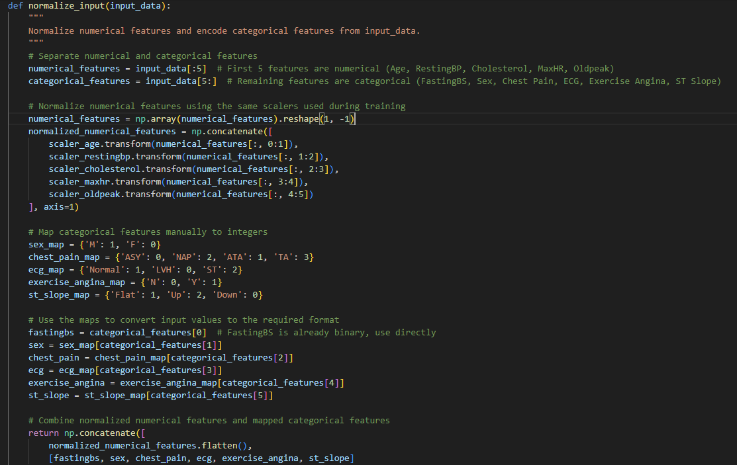
- Then create a function to call the model and input the information 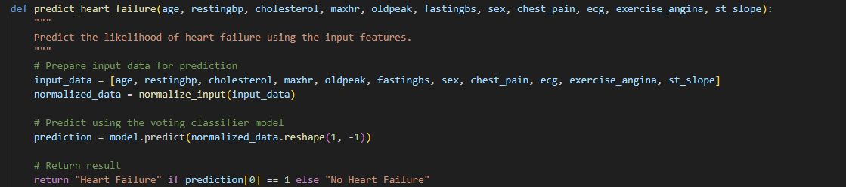
- Then create the Gradio interface which calls upon the functions created 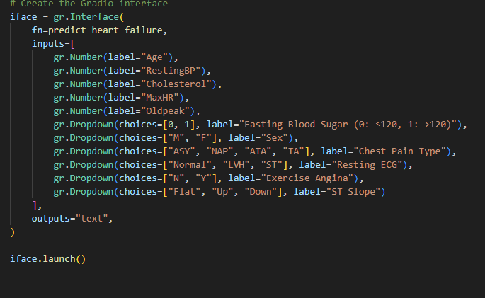
- Finally launch the Gradio and input your information and receive outputs! 